Shujaa SMS Gateway Administrator Guide

A Product of Shujaa Solutions Limited

2013

www.shujaa.co.ke

http://shujaa.mobi

info@shujaa.co.ke

2013



INFORMATION IN THIS DOCUMENT IS PROVIDED IN CONNECTION WITH SHUJAA SOLUTIONS’ PRODUCTS. NO INTELLECTUAL PROPERTY RIGHTS, LICENSE, EXPRESS OR IMPLIED, BY ESTOPPEL OR OTHERWISE, IS GRANTED BY THIS DOCUMENT, EXCEPT AS PROVIDED IN SHUJAA SOLUTIONS’ TERMS AND CONDITIONS OF SALE FOR SUCH PRODUCTS. SHUJAA SOLUTIONS ASSUMES NO LIABILITY WHATSOEVER, AND SHUJAA SOLUTIONS DISCLAIMS ANY EXPRESS OR IMPLIED WARRANTY, RELATING TO SALE AND/OR USE OF SHUJAA SOLUTIONS’ PRODUCTS INCLUDING LIABILITY OR WARRANTIES RELATING TO FITNESS FOR A PARTICULAR PURPOSE, MERCHANTABILITY, OR INFRINGEMENT OF ANY PATENT, COPYRIGHT OR OTHER INTELLECTUAL PROPERTY RIGHT.

The Programs (which include both the software and documentation) contain proprietary information; they are provided under a license agreement containing restrictions on use and disclosure and are also protected by copyright, patent, and other intellectual and industrial property laws. Reverse engineering, disassembly, or decompilation of the Programs, except to the extent required to obtain interoperability with other independently created software or as specified by law, is prohibited.

The Programs are not intended for use in any nuclear, aviation, mass transit, medical, or other inherently dangerous applications. It shall be the licensee's responsibility to take all appropriate fail-safe, backup, redundancy and other measures to ensure the safe use of such applications if the Programs are used for such purposes, and we disclaim liability for any damages caused by such use of the Programs.

Shujaa Solutions may make changes to specifications and product descriptions at any time, without notice.

No part of this publication may be reproduced, transmitted, transcribed, stored in a retrieval system, or translated into any language or computer language, in any form or by any means, electronic mechanical, magnetic, optical, chemical, manual, or otherwise, without the prior written permission of Shujaa Solutions Ltd.

Copyright © 2013 by Shujaa Solutions Ltd. All rights reserved.

All other trademarks are property of their respective owners.

Shujaa Solutions Ltd.

InTrade Africa Place, Kauria Close

Off Muthangari Road, Lavington

P.O. Box 48183 – 00100

Nairobi, Kenya

Table of Contents

1. Preface 3

1.1. Document Conventions 3

1.2. Related Documents 3

2. Introduction 4

2.1 About Sema SMS 4

2.2 Feature highlight 4

3. Installation 5

3.1. System Requirements 5

3.2. Installation Procedure 6

3.3. Configuration & Tuning 7

4. System Administration 9

4.1 All inbox 9

4.2 All incoming SMS 10

4.3 All outgoing SMS 10

4.4 Manager user 11

4.5 User credit 13

4.6 Reports 13

5. Maintenance 14

5.1. Backup & Restoration 14

5.2. Log File Management 14

5.3. Application of System Updates 14

6. Monitoring 14

7. Troubleshooting 14

8. Appendices 15

A. Glossary 15

B. References 15

# 1. Preface

## 1.1. Document Conventions

## 1.2. Related Documents

# 2. Introduction

## 2.1 About Sema SMS

SemaSMS is a flexible Web-based Mobile Portal System that it can be made to fit to various services such as an SMS gateway, bulk SMS, personal messaging systems, corporate and group communication tools.

## 2.2 Feature highlight

* Send SMS to single mobile phone (web2mobile)
* Send SMS broadcasted to a group of mobile phones (web2mobiles, bulk SMS)
* Support sending text, flash and unicode message
* Receive private SMS to Inbox and forward it to email (mobile2web)
* Forward single SMS from mobile to a group of mobile phones (mobile2mobiles)
* SMS autoreply, for easy autoreplying formatted incoming SMS
* SMS board, forward received SMS to email, html and/or xml page
* SMS command, execute server side shell script using SMS
* SMS custom, forward incoming SMS to custom application, locally or external URL
* SMS poll, manage polling system using SMS
* SMS quiz, serve quizzes on SMS
* SMS subscribe, manage user subscribes to a service using SMS
* Simple webservices for sending SMS and retrieving delivery reports
* Long SMS support, length of text is configurable
* Rate SMS by destination prefix
* SMS credit system per user
* Timezone settings
* Easily add new language for user interface
* Web-based interface

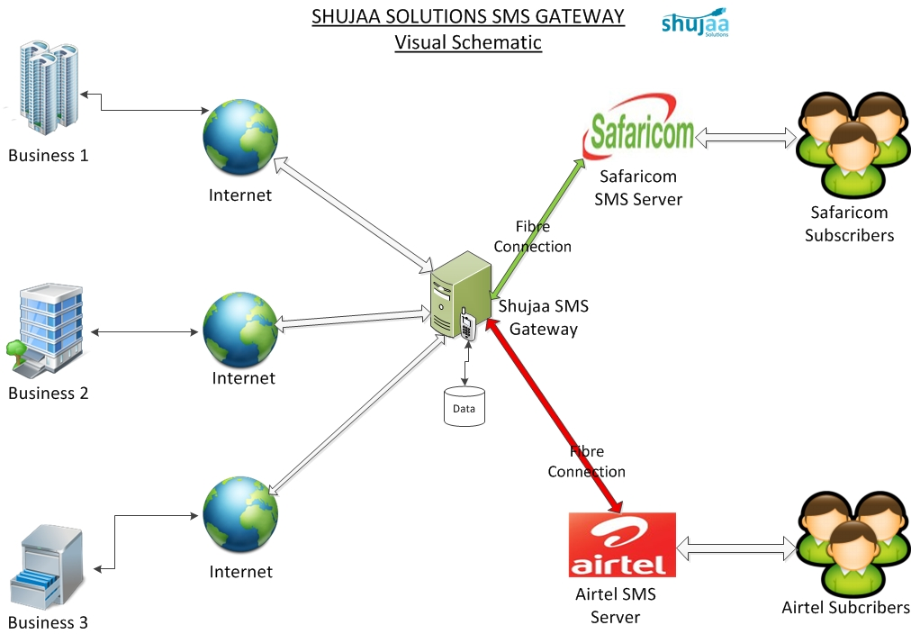

Figure 2.1: Shujaa SMS Gateway Overview

# 3. Installation

## 3.1. System Requirements

The minimum software requirements are as follows:

* Linux Operating System
* Web Server (Apache2)
* Database Server MySQL 5.x.x or latest stable release
* PHP 5.3.x or latest stable release with mysql module enabled and CLI version installed
* PHP gettext extension (this is a must for text translation)
* PHP multibyte string function (should be able to call mb_convert_encoding): this functionality is already included in the default installation of PHP5
* Access to an SMTP server (SemaSMS will use this to send email)
* Lynx, a console web browser
* Downloaded SemaSMS source from the Shujaa Solutions source code repository

**Minimum Required Server Administrator (or Developer)**

* Understand how to make sure installed PHP has MySQL module enabled/loaded
* Understand how to create/drop MySQL database
* Understand how to insert SQL statements into created database
* Basic knowledge to operate and manage Linux (skill to navigate in console mode)

## 3.2. Installation Procedure

Ensure the prerequisite software is installed in your system.

* The web server and database engine should be running
* Be sure to backup all the data you wish to preserve including databases.
* Ensure that the databases to be initialized are not open as the installation script runs.
* Set the appropriate variables at the beginning of the script according to your environment.
* Run the installation as the root user

WARNING! This installation procedure will drop any existing SemaSMS database and create another one. This process is irreversible therefore complete loss of data.

**SemaSMS Web Interface step-by-step installation:**

1. It is important to meet all minimum requirements above.
2. Checkout the latest version of SemaSMS from Shujaa Solutions repository
3. Change to system root user account to perform this installation.
4. Edit the config file located at *[root-folder]/SemaSMS2/trunk/webapp/etc/config/semasms.config*  and change the mysql root user password to match your mysql installation.
5. Run the *fullSetup.sh* script located at *[root-folder]/SemaSMS2/trunk/webapp/bin/fullsetup.sh* to perform a clean installation. If you have an existing installation and you only want to restore the database, run *dbRestore.sh*
6. After this, you can log in to SemaSMS via <http://sema.shujaa.mobi> on Shujaa Solutions live servers or <http://[your-ip-address]/sema.shujaa.mobi> on a local environment with the default account *admin* and password *admin*.

Now, you can log in to SemaSMS, create users and configure the system as per the user or client requirements.

## 3.3. Configuration & Tuning

**First login**

Access the login screen as described in the above procedure . Enter a user name and password. Since the system has just been installed and no users have yet been created, login as SemaSMS administrator first, using *'admin’* for username and *'admin'* for password.

***Warning:*** This account data is valid on every newly installed SemaSMS system. You should change the password for the SemaSMS administrator as soon as possible! This can be done via the manage user option under Administration menu for the SemaSMS administrator account.

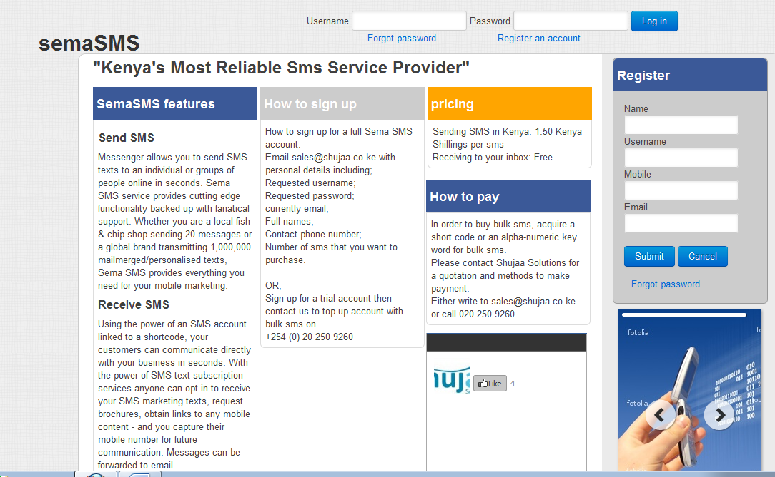

**Configurations:**

Upon successfully logging into the system, you are presented with the Dashboard page

(See figure below).

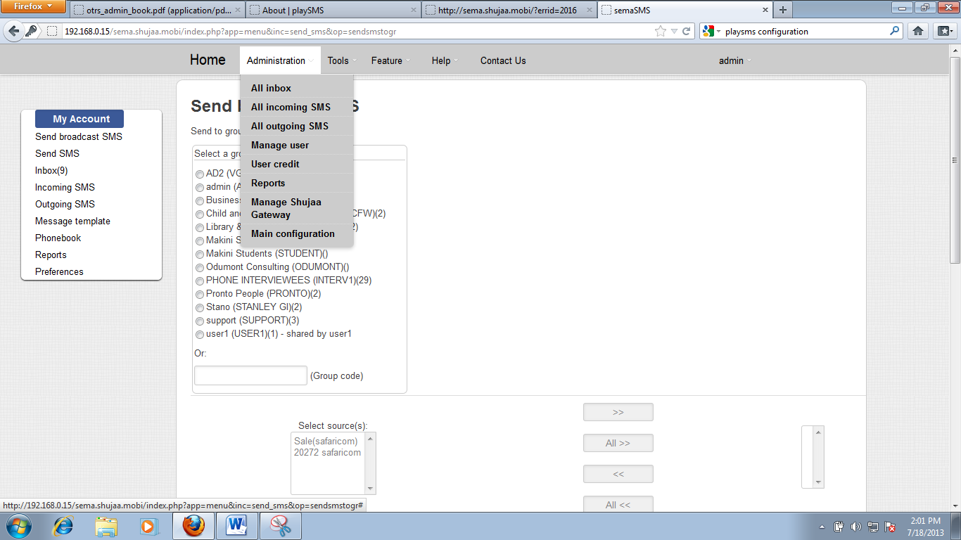

To configure SemaSMS, open the administration tab on the main menu.

**Main configuration**

Main configuration item on the administration menu enables the administrator to set the mail configurations required for the system to send emails.

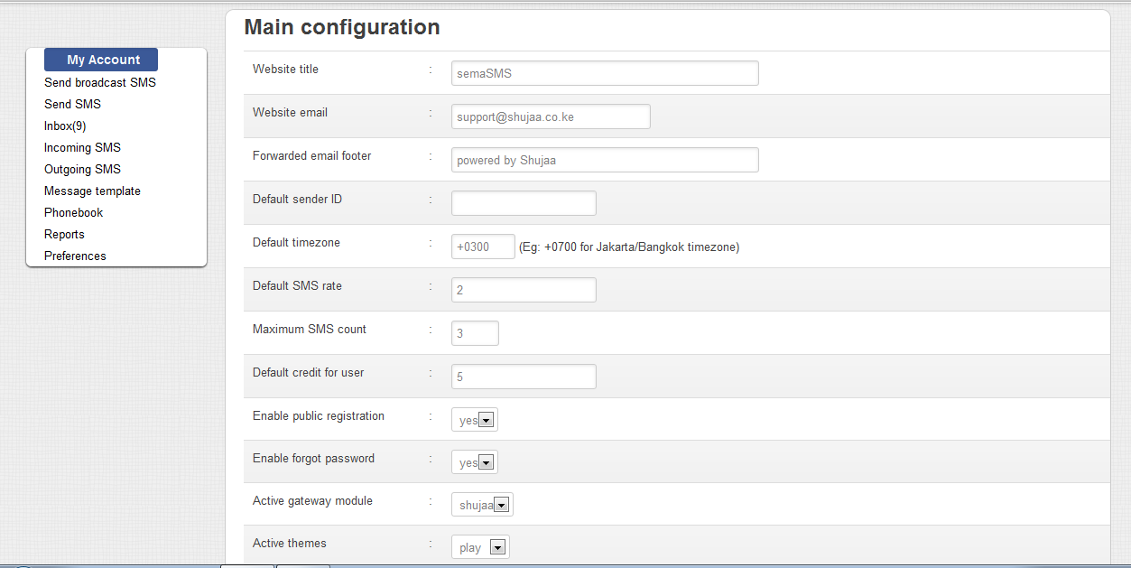

**Manage Shujaa Gateway**

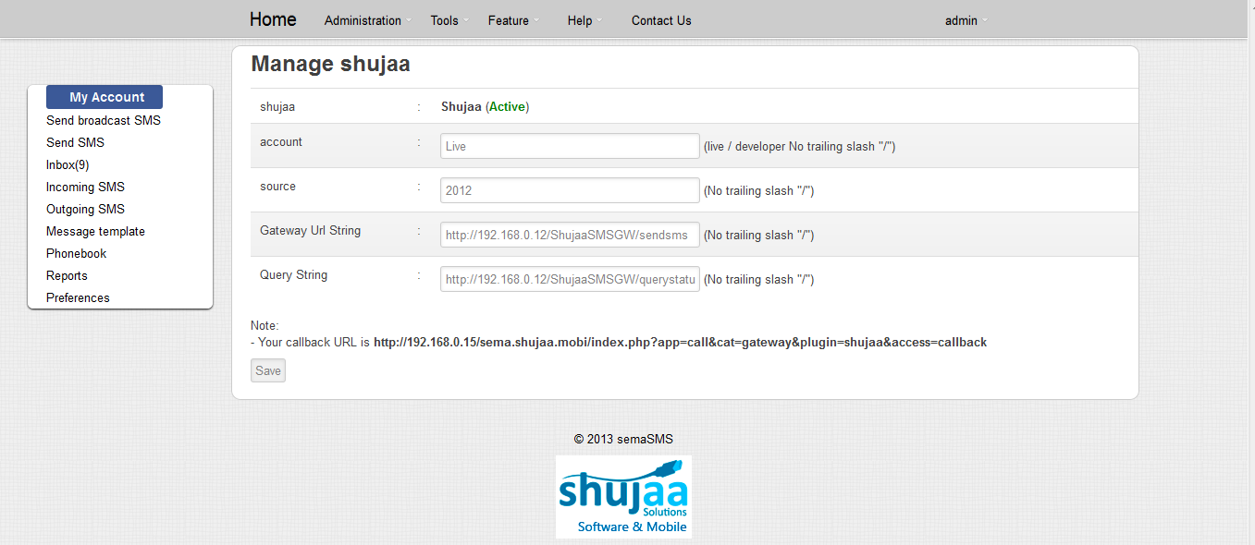

This menu item will provide an interface for the administrator to set the Shujaa SMS Gateway configurations for the SemaSMS system.

Set the gateway callback URL, account type, short code and the response query string.

# 4. System Administration

## 4.1 All inbox

The All inbox menu item contains all the SMS received by all users registered on SemaSMS system. SemaSMS administrator can be able to view incoming messages to all users in the system. Administrator can delete messages belonging to any user in the system.

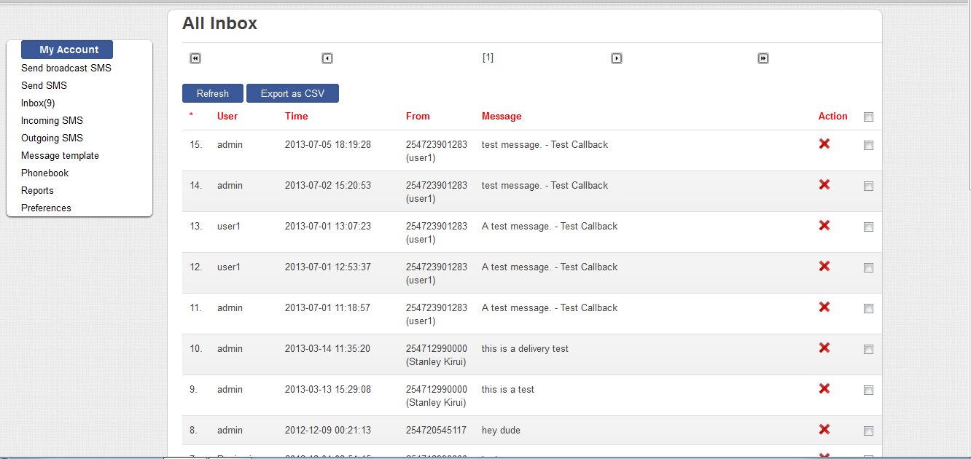

## 4.2 All incoming SMS

All incoming SMS contains both inbox messages and messages generated by the system features. This will include all messages for all users and the messages that are generated by features like SMS autoreply and SMS subscriptions.

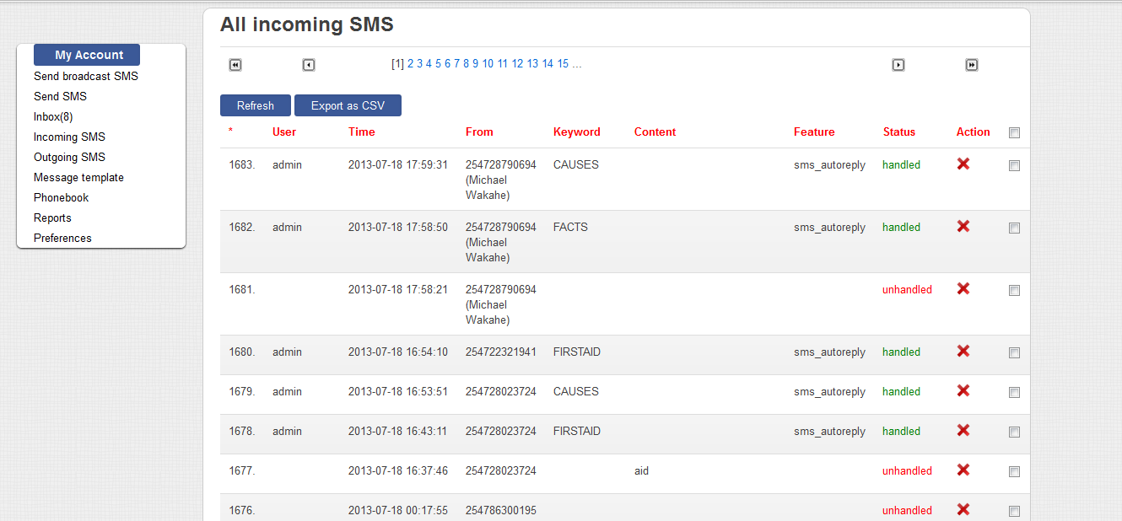

## 4.3 All outgoing SMS

All outgoing SMS contains all messages sent from SemaSMS system to the users or subscribers. It contains user outgoing and system feature messages originating from SemaSMS

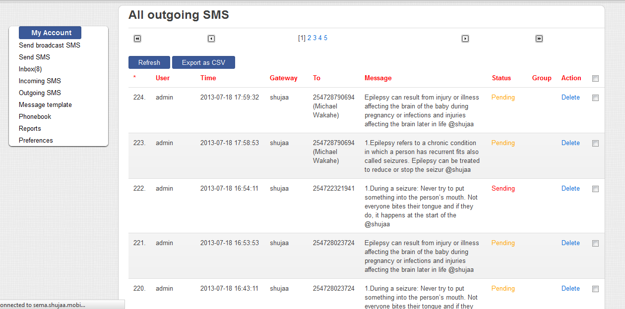

## 4.4 Manager user

Manage user page allows the administrator to manage existing users and add new users to the system. This page grants the administrator rights to edit any SemaSMS user.

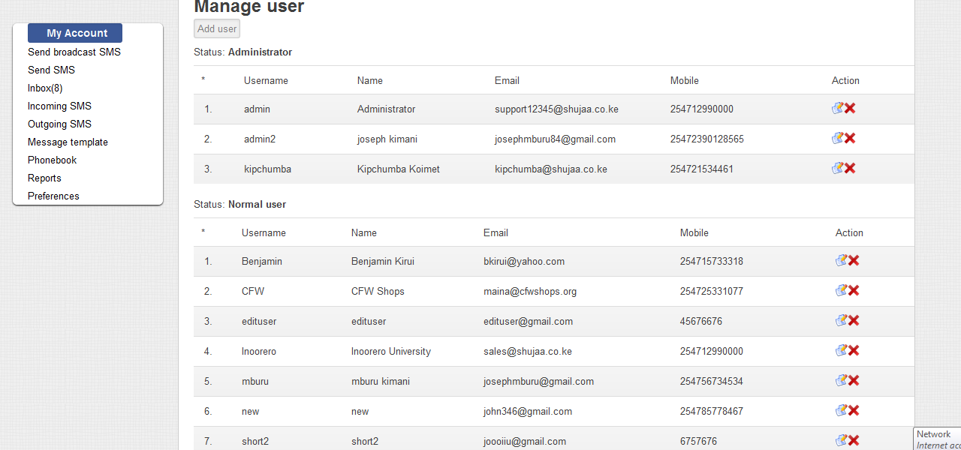

1. **Add new user**

To add a new user to SemaSMS, you need to enter the following details

* Username
* Full name
* Email
* Mobile
* SMS sender ID
* SMS footer
* Timezone
* Password
* User level
* Active language

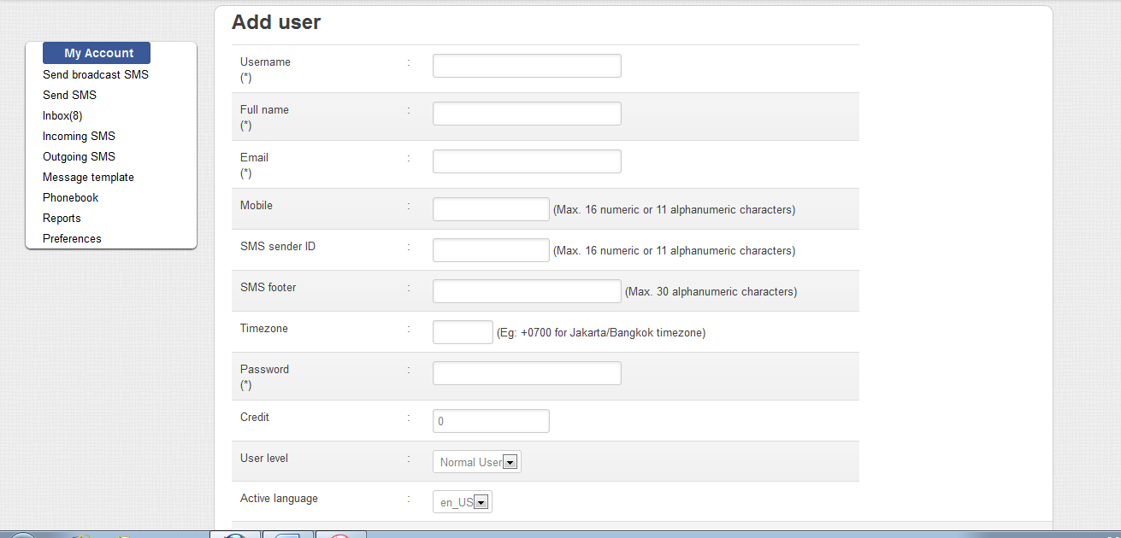

1. **Assign masks and short-code to users**

You must assign a user a SMS mask or a SMS short code or both but at least one of the two must be assigned. You can also assign a single user more than one mask or more than one short code.

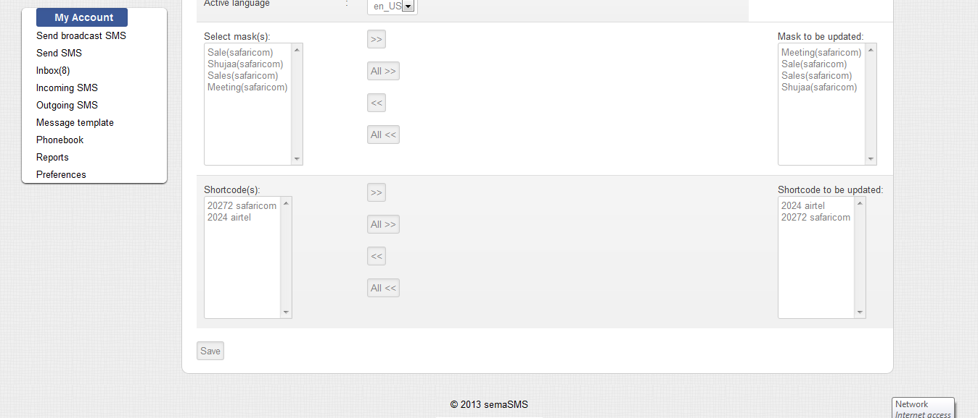

1. **Edit User**

Edit user page allows the administrator to edit the details of an existing SemaSMS user. SemaSMS administrator can change all the information of every user in the system.

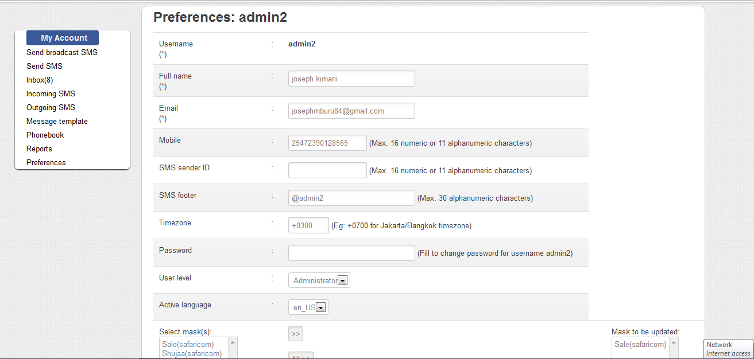

## 4.5 User credit

Every user must have credit to be able to send SMS from SemaSMS.

SemaSMS administrator can add credit to user from this page. You must specify username, credit amount and the mask or short code to top up

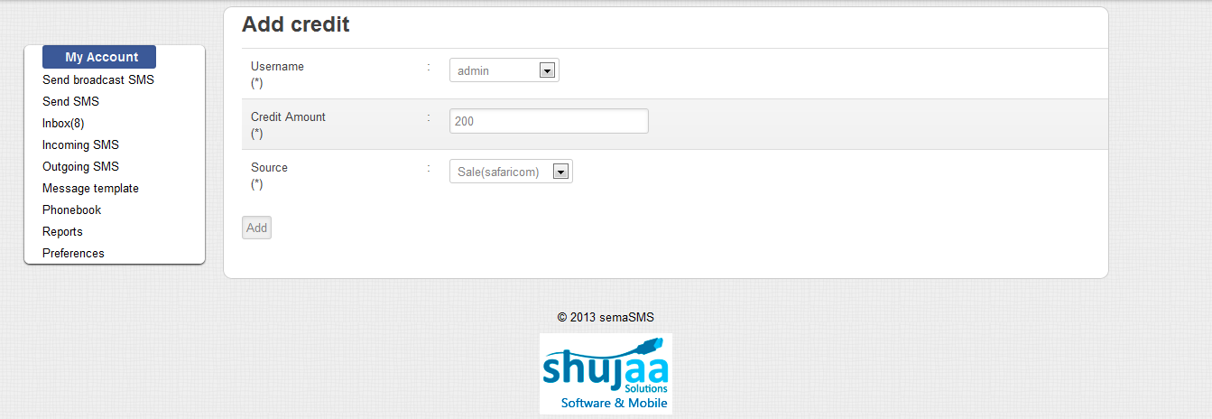

## 4.6 Reports

SemaSMS administrator can view the activity summary of incoming and outgoing SMS in a detailed graphical view. The following is the breakdown of the system reports:

* Summary of all account activity
* Daily SMS activities
* Incoming and outgoing SMS per day
* Outgoing SMS per network
* Incoming SMS per network

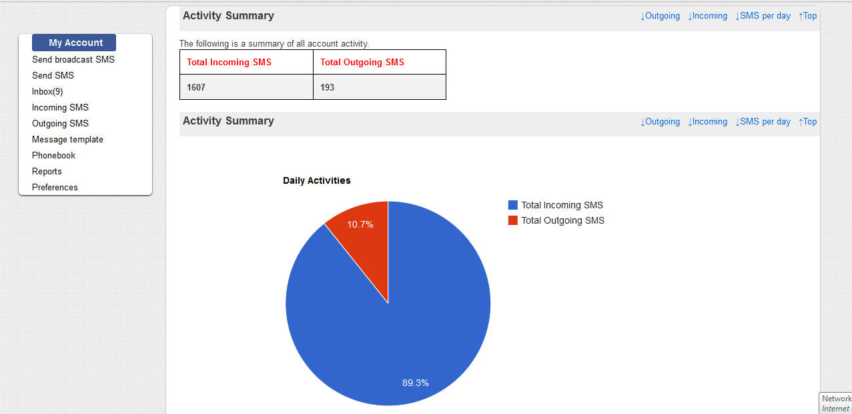

# 5. Maintenance

Routine maintenance tasks. Examples include:

## 5.1. Backup & Restoration

## 5.2. Log File Management

## 5.3. Application of System Updates

# 6. Monitoring

How to view system performance, for example how to generate reports, view log files etc.

# 7. Troubleshooting

Basic guide on how to fix commonly occurring system errors.

# 8. Appendices

## A. Glossary

|  |  |
| --- | --- |
| API …………………………………………… | Application Programmer Interface |
| CCK ………………………………………….. | Communications Commission of Kenya |
| HTTP ………………………………………... | Hyper Text Transfer Protocol |
| J2EE ……................................................... | Java 2 Enterprise Edition |
| MO …………………………………………... | Mobile Originated SMS |
| MSISDN …………………………………… | A number uniquely identifying a subscription in a GSM mobile network |
| MT …………………………………………… | Mobile Terminated SMS |
| PRSP ………………………………………… | Premium Rate Services Provider |
| SLA …………………………………………. | Service Level Agreement |

## B. References

Books, journals, course materials or websites where literature is found.

This is how you reference a book:

Author, A. A., Author, B. B. & Author, C. C. (year of publication). *Title of book: Subtitle*. (Edition [if not first]). Place of publication: Publisher.

For example:

Book with one author:

Adair, J. (1988) *Effective time management: How to save time and spend it wisely*, London: Pan Books.

Book with two authors:

McCarthy, P. and Hatcher, C. (1996) *Speaking persuasively: Making the most of your presentations*, Sydney: Allen and Unwin.

